How to Install R

Open an internet browser,

And go to [www.**r**-project.org](http://www.r-project.org)

Click on the CRAN link below the Download header

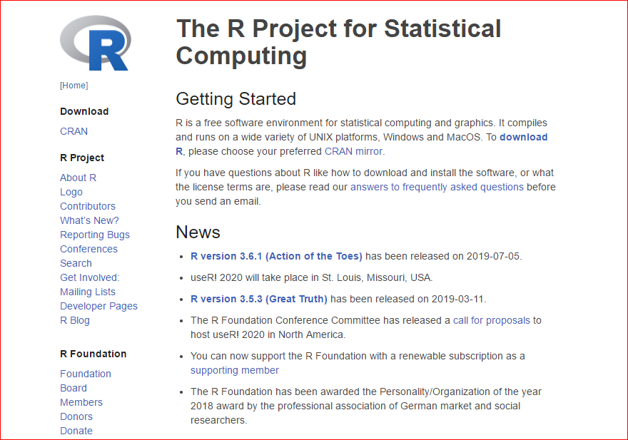

Find a CRAN mirror website close to you. Scroll down as needed.

For example, in Michigan, the <https://cran.mtu.edu/> site is nearby.

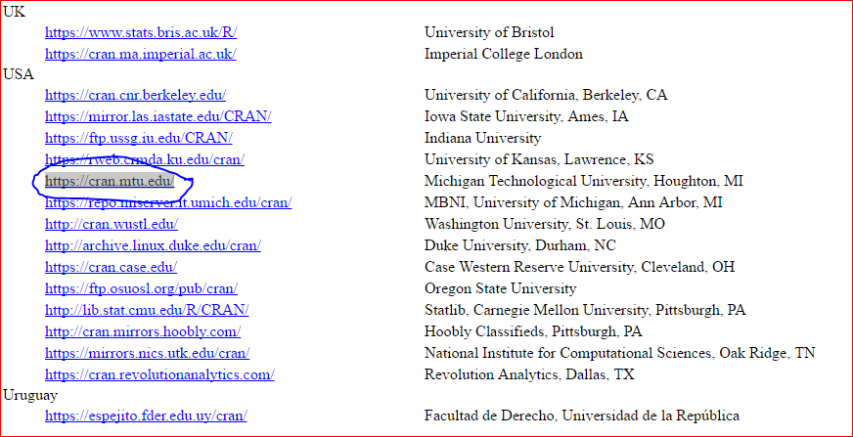

Click on the appropriate CRAN mirror link,

And you will go to this page

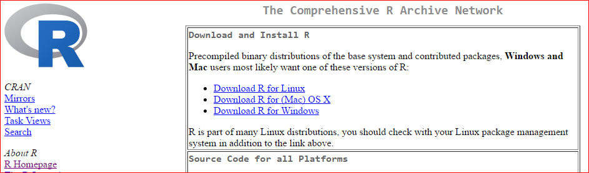

Select either Linux, Mac, or Windows, and click on the correct link for your computer.

The Windows version looks like this

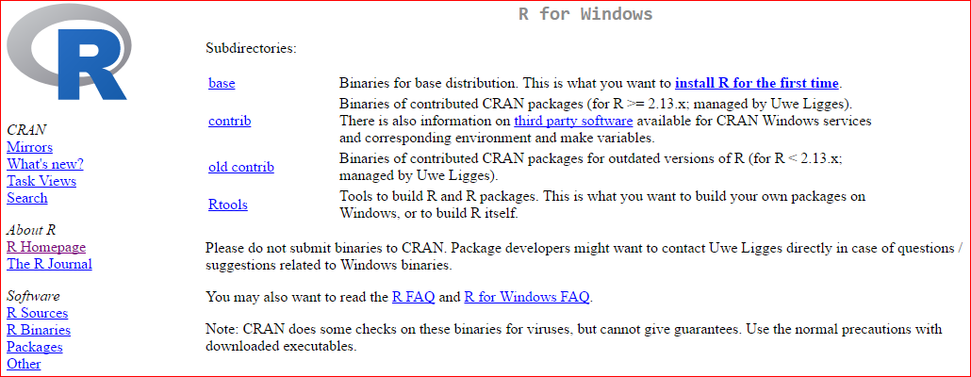

Click on the Download R for the first time link at the top right

Which will give you this page

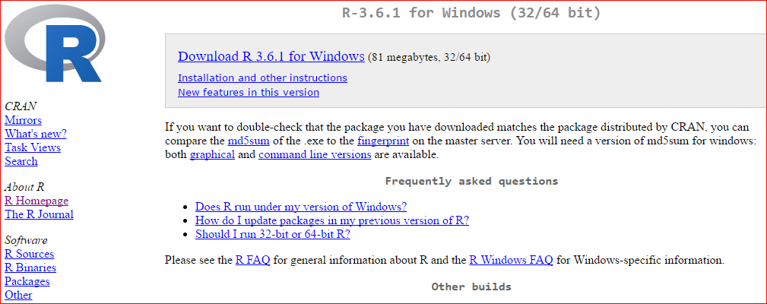

Now click on the Download R 3.6.1 for Windows link

In Windows 10, this will appear as a tab at the bottom left of your browser for

R-3.6.1-win.exe

Use the arrow to open the file.

Follow all the defaults (and pick a language) to Install it. Lots of clicking Next buttons.

Finish to exit setup.

For Windows users, it is also a good idea to download and install Rtools.exe

(Mac users will use tools on the Mac page, including GNU Fortran)